Evaluating factors affecting customer churn at Telco, a fictitious company

Fouad Yared

Hunter College, Statistics 791 Independent Study, Fall 2020

Purpose

One of the many ways the economy has changed in recent years is through the rise of subscription-based businesses. According to Stanford Business, “In recent years, this market has grown by more than 100% a year, increasing from $57 million in sales in 2011 to $2.6 billion in 2016, according to one expert.” A key metric for subscription-based companies is churn, or how many of its customers decide to leave a service. The purpose of this analysis is to evaluate factors that affect churn at Telco, a fictious company that provides home phone, internet, and internet-based services for its ~7,000 customers in California. (IBM provided the data as part of its Cognos Analytics platform.3 It is publicly available on Kaggle.1)

The Telco data includes several features on customers: their demographics and location, the services they are subscribed to, and their status with the company. Survival analysis, which looks at the time until an event occurs, will be used to better understand the relationship of various predictors against the tenure (in months) a customer has with the company. The event is Churn Value, a binary variable that looks at whether a customer decided to continue or discontinue their business with Telco that quarter. The outcome variable, Tenure, reflects the number of months a person has been a customer with the company. Other variables will serve as predictors. The data set consists of 7,043 customers.

Data Exploration

Bar plots and histograms were used to look at various aspects of the Telco data, as shown in the set of charts in the appendix. Most customers (73%) stayed with the company in the third quarter. Regarding tenure, most customers have been with the company for over twelve months, over 600 signed on in the previous month, and eleven signed on in the current month. Most customers are younger than 65, customers who have and do not have partners are evenly split, and the majority of customers have dependents. Customers tend to be neutral, satisfied, or very satisfied (scores 3 to 5) with the company and tend to sign month-to-month contracts. Phone service and fiber-optic internet service are common among most customers. The total charges for customers (approximately, the monthly charge multiplied by the tenure) are usually under $2,000 and the predicted customer lifetime value ranges between $4-$8,000. Although not shown in the graphs, internet-services (online security, streaming movies) were related to whether someone had purchased internet through the company.

Relationships between Variables

Numeric and categorical variables were evaluated separately to better understand their relationship with each other along with Churn Value and Tenure. Referencing the correlation plot found in the appendix, Churn Value had a high correlation with Churn Score (which predicts whether a customer will leave based on other covariates and gives a score from 0-100, where the higher the score the more likely the customer will churn). Total Revenue (lifetime revenue earned from a customer), Total Charges Present (lifetime amount charged to a customer), Monthly Charges, and Tenure all had a high correlation with one another.

To evaluate the relationship among categorical variables, mosaic plots and Cramer’s V statistics were used. The mosaic plots compare counts of one categorical variable against counts that a customer will churn. When looking at satisfaction scores, we see that 100% of the customers who said they were Very Unsatisfied or were Unsatisfied with the company (a “1” or “2”) left the company. Conversely, 100% of the customers who were Satisfied or Very Satisfied (a “4” or “5”) stayed with the company. The majority who scored the company as Average (a “3”) stayed. When looking at contract types, of those who have a month-to-month contract, 42% left the company compared to 7% of those with a one-year and 3% of those with a two-year contract. The rate of churn for certain marketing offers that customers accepted varied. Over 52% of those who accepted Offer E ended up leaving the company in the current quarter while only 6% of those who accepted Offer A left this quarter.

The bar plot shows the relationship of Churn Status and other binary nominal variables using Cramer’s V. Values for Cramer’s V range from 0 (where there is no association) to 1 (where one variable is completely determined by the other). Notably, Churn Reason is only provided for customers who left which is why there is a very strong relationship with Churn Status. Other variables have milder relationships and will be retained for modeling. Although not pictured, the Cramer’s V statistics were calculated for phone, internet, and internet-related variables. Many Internet-related variables (e.g., Online Security, Streaming Movies) only had values when the customer was provided internet from the company. Otherwise, the values for the internet-related variables were completely determined (as the Cramer’s V statistic was 1) when internet was not provided by the company. All internet-related variables were not included in modeling.

Evaluating Kaplan-Meier Survival Plots

Three KM Survival plots were evaluated using satisfaction scores, contract length, and offer accepted. Log rank tests were used to evaluate whether the curves were the same (the null hypothesis) or whether they were different. Since the p-values for all three KM plots were under 0.05, we conclude the survival curves in each of the plots are different from one another.

Variable Selection

Variables related to customer tenure or churn status were not included in the model. These include Total Charges, Total Revenue, Churn Score, and Customer Lifetime Value, among others. Instead of using tenure-related features like Total Charges when developing Cox models, Monthly Charges were used. Since Monthly Charges were retained in the model, individual line-items (e.g., Phone Service, Internet Service, Average Monthly Long Distance Charges, Streaming Music) were not included. As described in Table 1 below, twelve predictors were used in the model (rows 13 and 14 are the Event and Response variables, respectively).

Conducting backwards variable selection

Backwards variable selection was conducted using the selectCox() function in R. AIC was used as a determining factor. Five of the twelve predictors included in the model were removed. These are the four demographic predictors (Senior Citizen, Partner, Under 30, and Gender) and whether the customer has Paperless Billing. Stand-alone Cox models were fit using the remaining seven variables.

|  |  |  |  |  |
| --- | --- | --- | --- | --- |
| Table 1: Variables included in initial Cox model | | | | |
| # | Type | Variable Name | Description | Variable Type |
| 1 | Pred | Senior Citizen | Indicates whether customer is 65 or older | Binary (Yes/No) |
| 2 | Pred | Partner | Indicates whether customer is married | Binary (Yes/No) |
| 3 | Pred | Under 30 | Indicates whether someone in home is under 30 | Binary (Yes/No) |
| 4 | Pred | Gender | Indicates customer's gender | Binary (Male/Female) |
| 5 | Pred | Contract | Indicates customer's current contract type | Categorical (Month-to-month, one year, two year) |
| 6 | Pred | Paperless Billing | Indicates if customer has chosen paperless billing | Binary (Yes/No) |
| 7 | Pred | Payment Method | Indicates how customer pays their bills | Categorical (automatic bank transfer, automatic credit card, mailed check, electronic check) |
| 8 | Pred | Number of Dependents Group | Indicates number of dependents that live with customer. Dependents can be children, parents, grandparents, etc | Numeric (0-10) |
| 9 | Pred | Number of Referrals Group | Indicates number of referrals customer has made | Numeric (0-4) |
| 10 | Pred | Offer | Identifies the last marketing offer the customer accepted, if applicable | Categorical (None, Offer A, B, C, D, and E) |
| 11 | Pred | Monthly Charges | Indicates customer's current total monthly charge for all services from the company | Numeric (18.25-118.75) |
| 12 | Pred | Satisfaction Score Group | A customer's overall satisfaction with the company, from 1 (very unsatisfied) to 5 (very satisfied) | Categorical (scores of 1 and 2 are grouped together; scores of 3-5 are grouped together) |
| 13 | Event | Churn Value | Whether the customer left the company this quarter or not | Binary ("1" means customer left company this quarter, "0" means customer stayed this quarter) |
| 14 | Resp | Tenure in Months | Total number of months the customer has been with the company | Numeric (0-72) |

|  |  |  |  |
| --- | --- | --- | --- |
| Table 2: Intercept values in initial Cox model | | | In post-variable selection Cox Model? |
| 1 | Senior Citizen | Not a Senior Citizen | N |
| 2 | Partner | Does not have a partner | N |
| 3 | Under 30 | No one in home is under 30 | N |
| 4 | Gender | Customer is female | N |
| 5 | Contract | Contract is for two years | Y |
| 6 | Paperless Billing | Does not have paperless billing | N |
| 7 | Payment Method | Uses automatic credit card for payment | Y |
| 8 | Number of Dependents Group | Numeric; no default value | Y |
| 9 | Number of Referrals Group | Numeric; no default value | Y |
| 10 | Offer | Accepted Offer A | Y |
| 11 | Monthly Charges | Numeric; no default value | Y |
| 12 | Satisfaction Score Group | Grouped satisfaction score of 3, 4, or 5 (Neutral to Satisfied to Very Satisfied) | Y |
| 13 | Churn Value | Not applicable | Event variable |
| 14 | Tenure in Months | Not applicable | Response variable |

Fitting Cox models

Initially, two Cox models were fit: one was the full twelve variable model and the other was a reduced model with only the seven variables from backwards selection. Performing a log-likelihood test on the full and reduced models led to a p-value of 0.1236. Since the p-value for the log-likelihood test is >= 0.05, we use the reduced model. Table 2 shows the intercept values for variables in the Cox model before and after variable selection.

Interpreting Final Cox Model

Variables and variable-levels (for categorical variables) not included in the intercept can be found in the first column of Table 3 and their associated coefficients are found in the second column. The third column shows the hazard rate, which exponentiates the coefficients for each variable. The fourth and fifth columns show the standard error and z-scores, respectively. The sixth column shows p-values. (While all variables had significant p-values, two levels of categorical variables were not significant.) The seventh and eighth columns show the 2.5% and 97.5% confidence intervals for the hazard rate. Highlighted values consist of very high hazard rates, non-significant p-values greater than 0.05, and confidence intervals that include the baseline hazard ratio of 1 (which are related to p-values greater than 0.05). Overall, the length of a customer’s contract, the marketing offer they accepted, and the customer’s overall satisfaction play key roles in determining how long a customer stays with the company. The magnitude of each of these effects, when controlling for the effects of other variables, is described below.

The length of a customer’s contract has the single largest effect on the hazard rate. Customers with a month-to-month contract have a hazard rate that is 16.27 times higher than those with a two-year contract. Similarly, customers with a one-year contract have a hazard rate that is 4.60 times higher than those with a two-year contract. In other words, the longer a customer’s contract, the longer their tenure with the company.

The last marketing offer a customer accepted had the second largest effect on how long a customer stayed with the company. The base rate is for customers that accepted Offer A. The hazard rate for customers who accepted Offer E was 14.37 times as large as it was for those who accepted Offer A; the hazard rate for customers who accepted Offers C, D, and no offer were 2.19, 3.21, and 3.06 times as large as the hazard rate for those who accepted Offer A, respectively. (The hazard rate for those that accepted Offer B is not significantly different from the hazard rate for those who accepted Offer A, so the results will not be interpreted.) Details on the various offers were not included in IBM’s data description, but it is likely that the terms of certain offers may favor shorter or longer tenures with the company.

The overall satisfaction of a customer also played a key role in determining how long a customer decided to stay with the company. Customers who stated they were unsatisfied or very unsatisfied had a hazard ratio of 9.88 times that of customers who said they were neutral, satisfied, or very satisfied with the company. Improving customer’s satisfaction (or perception) would help retain customers.

We expect the hazard rate for customers that use an electronic check to increase by 54% and for those who use a mailed check to increase by 83%, compared to those who use an automatic credit card. (The hazard rate for those who used an automatic bank transfer is not significantly different from the hazard rate for those who used an automatic credit card, so the results will not be interpreted.) The more effort a payment method requires (i.e., mailing a check requires more effort than an automatic payment), the more likely the customer will leave the company.

Regarding the numeric variables, a one unit increase in the number of dependents is associated with a 18% decrease in the expected hazard rate. Similarly, a one unit increase in the number of referrals is associated with a 22% decrease in the expected hazard rate. Customers with more dependents and referrals are more likely to stay with the company.

A one unit increase in Monthly Charges is associated with a 0.07% decrease in the expected hazard. To better understand how the amount paid each month affects tenure with the company, the Monthly Charges feature was split into four classes based on quartiles (<=$35, >$35-70, >$70-90, and >$90-120). (Since the Monthly Charges feature was changed, a new Cox model was fit. The set of coefficients for the reduced model is found in Table 4 below. The coefficients of the other variables are close to their previous coefficients.) Customers who pay $90-120 a month have a 35% lower hazard rate than customers who pay less than $35 a month. (The hazard rate for those who pay >$35-70 or >$70-90 a month is not significantly different from the hazard rate for those who pay less than $35 a month, so the results will not be interpreted.) There is not a clear relationship between how much a customer is charged each month and whether they will leave the company. The bar chart labeled “Median monthly charges by Tenure Length and Churn Status” shows there is a tendency for Monthly Charges to increase for each year a customer has been with the company. There is also a tendency for customers who leave to be paying more than customers who do not leave.

Evaluating Proportional Hazard Assumption

The null hypothesis for the Cox Model is that each variable has a constant hazard rate over time. The Proportional Hazard (PH) assumption for each of the variables are tested using the cox.zph() function in R. Values less than 0.05 reject the null hypothesis. Results are found in Table 5. The p-value for the PH assumption is below 0.05 for both the entire model (the Global line-item) and six of the seven variables in the final model. The violations to the PH assumptions are visualized in Chart 16 on Schoenfeld residuals. Time-related patterns are found in several of the plots, which are noticed as the number of months increases (the top-left plot on Beta residuals for the Contract length variable shows a curvilinear relationship with time).

Conclusions

The findings of the exploratory analysis and KM curves were helpful in generating an idea of which variables may be important. Conducting variable selection with a-priori knowledge and backwards selection (using AIC) helped reduce the feature space, so the final Cox model only used seven variables. By interpreting the final model, the largest effects on tenure with the company are the contract length, the type of marketing offer a customer accepted, and the payment method. More work can be done to address violations to PH assumptions.

|  |  |  |  |  |  |  |  |
| --- | --- | --- | --- | --- | --- | --- | --- |
| Table 3: Interpreting Seven-variable Cox Model (Monthly Charges are Numeric) | | | | | | | |
| Variable/Variable-level | coef | Hz | SE | z | Pval | Hz_2.5% | Hz_97.5% |
| Contract: Month-to-month | 2.8 | 16.27 | 0.2 | 16.7 | 0.00 | 11.7 | 22.6 |
| Contract: One year | 1.5 | 4.60 | 0.2 | 8.9 | 0.00 | 3.3 | 6.5 |
| Payment Method: Bank transfer (automatic) | 0.1 | 1.11 | 0.1 | 1.1 | 0.27 | 0.9 | 1.3 |
| Payment Method: Electronic check | 0.4 | 1.54 | 0.1 | 5.8 | 0.00 | 1.3 | 1.8 |
| Payment Method: Mailed check | 0.6 | 1.83 | 0.1 | 6.6 | 0.00 | 1.5 | 2.2 |
| Number of Dependents Group | -0.2 | 0.82 | 0.0 | -4.1 | 0.00 | 0.7 | 0.9 |
| Number of Referrals Group | -0.3 | 0.78 | 0.0 | -11.6 | 0.00 | 0.7 | 0.8 |
| Offer: None | 1.1 | 3.06 | 0.2 | 6.2 | 0.00 | 2.1 | 4.4 |
| Offer: Offer B | 0.1 | 1.15 | 0.2 | 0.7 | 0.49 | 0.8 | 1.7 |
| Offer: Offer C | 0.8 | 2.19 | 0.2 | 3.7 | 0.00 | 1.5 | 3.3 |
| Offer: Offer D | 1.2 | 3.21 | 0.2 | 5.8 | 0.00 | 2.2 | 4.8 |
| Offer: Offer E | 2.7 | 14.37 | 0.2 | 13.6 | 0.00 | 9.8 | 21.1 |
| Monthly Charges | 0.0 | 0.99 | 0.0 | -6.4 | 0.00 | 1.0 | 1.0 |
| Satisfaction Score Group: Rated 1 or 2 | 2.3 | 9.88 | 0.1 | 37.7 | 0.00 | 8.8 | 11.1 |

|  |  |  |  |  |  |  |  |
| --- | --- | --- | --- | --- | --- | --- | --- |
| Table 4: Interpreting Seven-variable Cox Model (Monthly Charges split into quartiles) | | | | | | | |
| Variable/Variable-level | coef | Hz | SE | z | Pval | Hz_2.5% | Hz_97.5% |
| Contract: Month-to-month | 2.8 | 16.01 | 0.2 | 16.6 | 0.00 | 11.5 | 22.2 |
| Contract: One year | 1.5 | 4.61 | 0.2 | 8.9 | 0.00 | 3.3 | 6.5 |
| Payment Method: Bank transfer (automatic) | 0.1 | 1.11 | 0.1 | 1.1 | 0.25 | 0.9 | 1.3 |
| Payment Method: Electronic check | 0.4 | 1.52 | 0.1 | 5.6 | 0.00 | 1.3 | 1.8 |
| Payment Method: Mailed check | 0.7 | 1.94 | 0.1 | 7.3 | 0.00 | 1.6 | 2.3 |
| Number of Dependents Group | -0.2 | 0.83 | 0.0 | -3.9 | 0.00 | 0.8 | 0.9 |
| Number of Referrals Group | -0.2 | 0.78 | 0.0 | -11.6 | 0.00 | 0.7 | 0.8 |
| Offer: None | 1.1 | 3.12 | 0.2 | 6.3 | 0.00 | 2.2 | 4.5 |
| Offer: Offer B | 0.2 | 1.20 | 0.2 | 0.9 | 0.38 | 0.8 | 1.8 |
| Offer: Offer C | 0.8 | 2.18 | 0.2 | 3.7 | 0.00 | 1.4 | 3.3 |
| Offer: Offer D | 1.2 | 3.22 | 0.2 | 5.8 | 0.00 | 2.2 | 4.8 |
| Offer: Offer E | 2.7 | 14.77 | 0.2 | 13.7 | 0.00 | 10.1 | 21.7 |
| Monthly Charges Group: >$35-70 | 0.0 | 0.98 | 0.1 | -0.2 | 0.82 | 0.8 | 1.2 |
| Monthly Charges Group: >$70-90 | 0.1 | 1.06 | 0.1 | 0.7 | 0.48 | 0.9 | 1.3 |
| Monthly Charges Group: >$90-120 | -0.4 | 0.66 | 0.1 | -4.4 | 0.00 | 0.5 | 0.8 |
| Satisfaction Score Group: Rated 1 or 2 | 2.3 | 9.68 | 0.1 | 37.5 | 0.00 | 8.6 | 10.9 |

|  |  |  |  |
| --- | --- | --- | --- |
| Table 5: Evaluating PH assumptions for Seven-variable Cox Model | | | |
| Variable | chisq | df | p |
| Contract | 59.10 | 2 | 0.00 |
| Payment Method | 16.19 | 3 | 0.00 |
| Number of Dependents Group | 18.89 | 1 | 0.00 |
| Number of Referrals Group | 0.50 | 1 | 0.48 |
| Offer | 667.58 | 5 | 0.00 |
| Monthly Charges | 24.28 | 1 | 0.00 |
| Satisfaction Score Group | 57.52 | 1 | 0.00 |
| GLOBAL | 851.79 | 14 | 0.00 |

Appendix

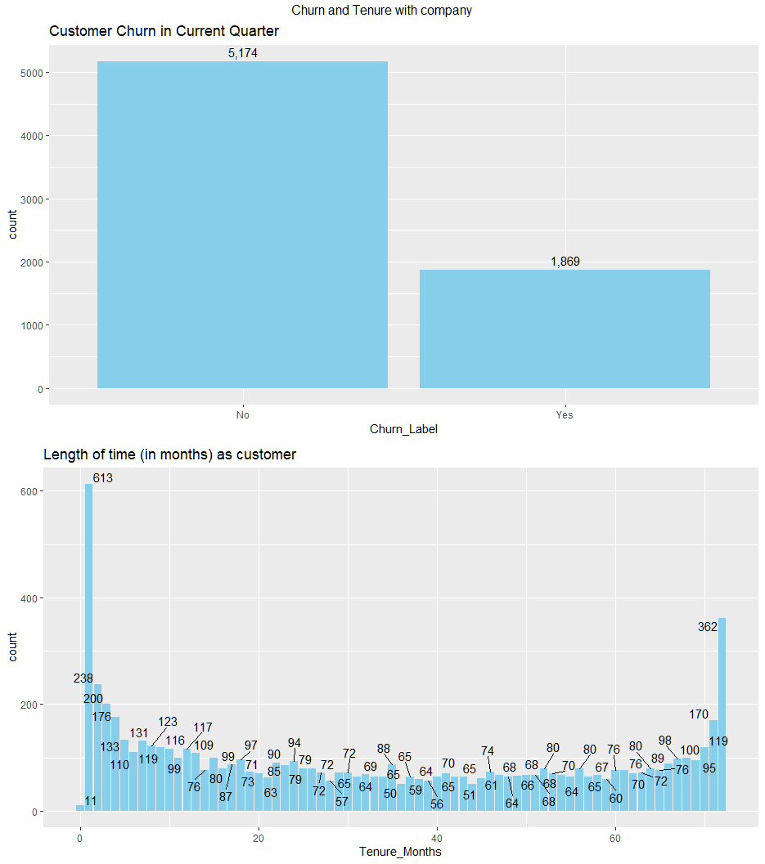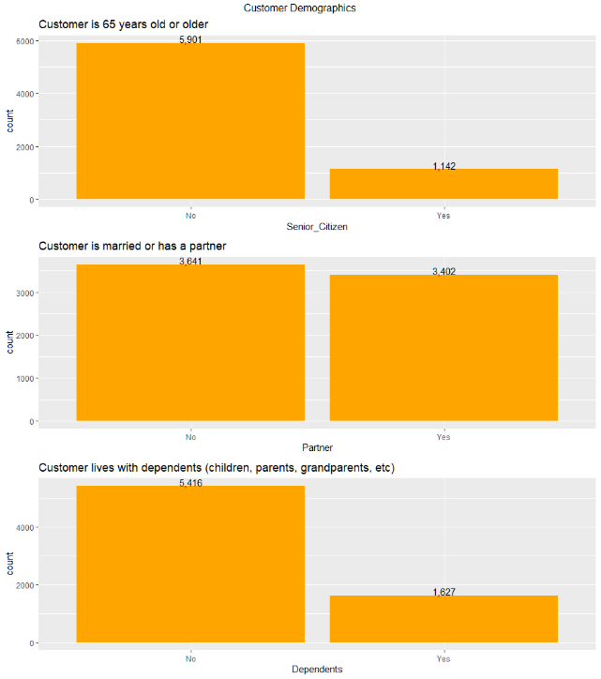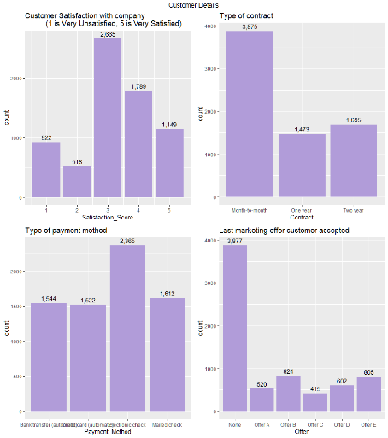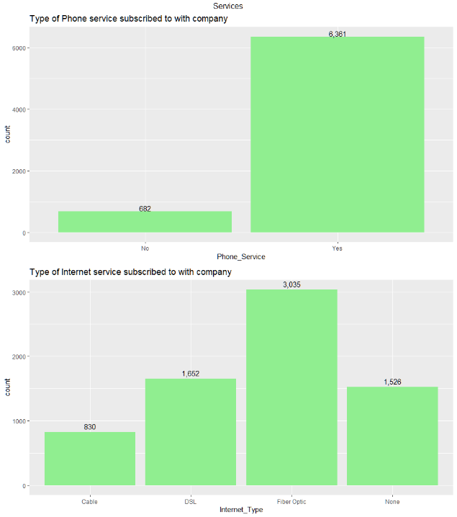

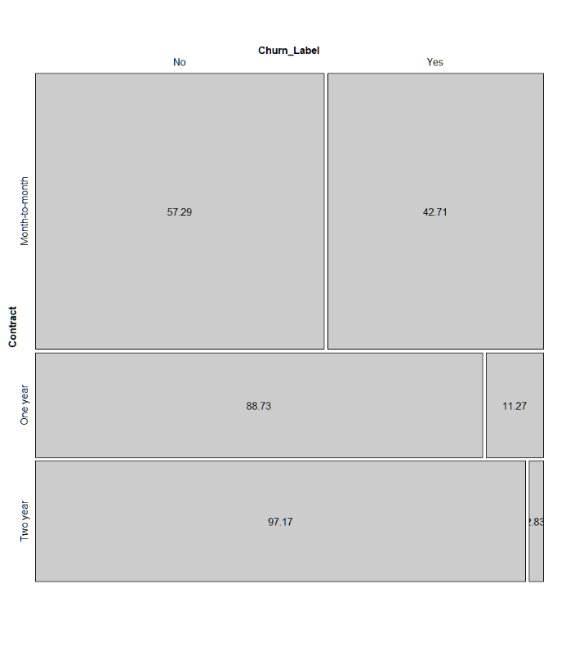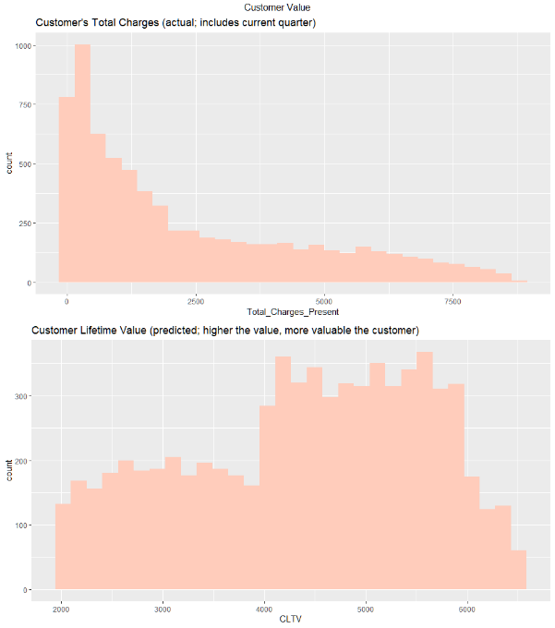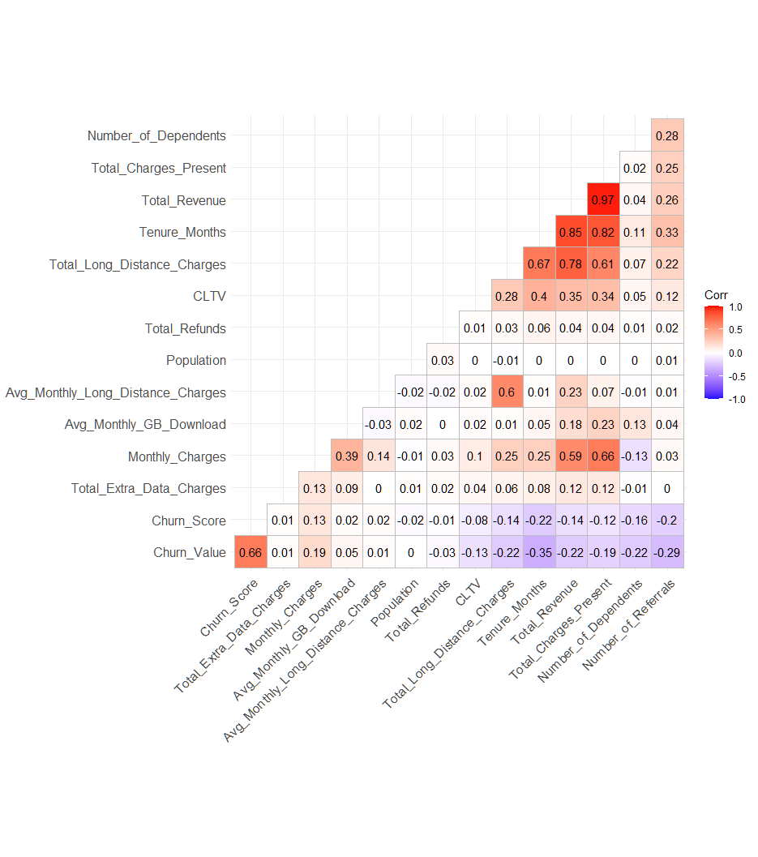 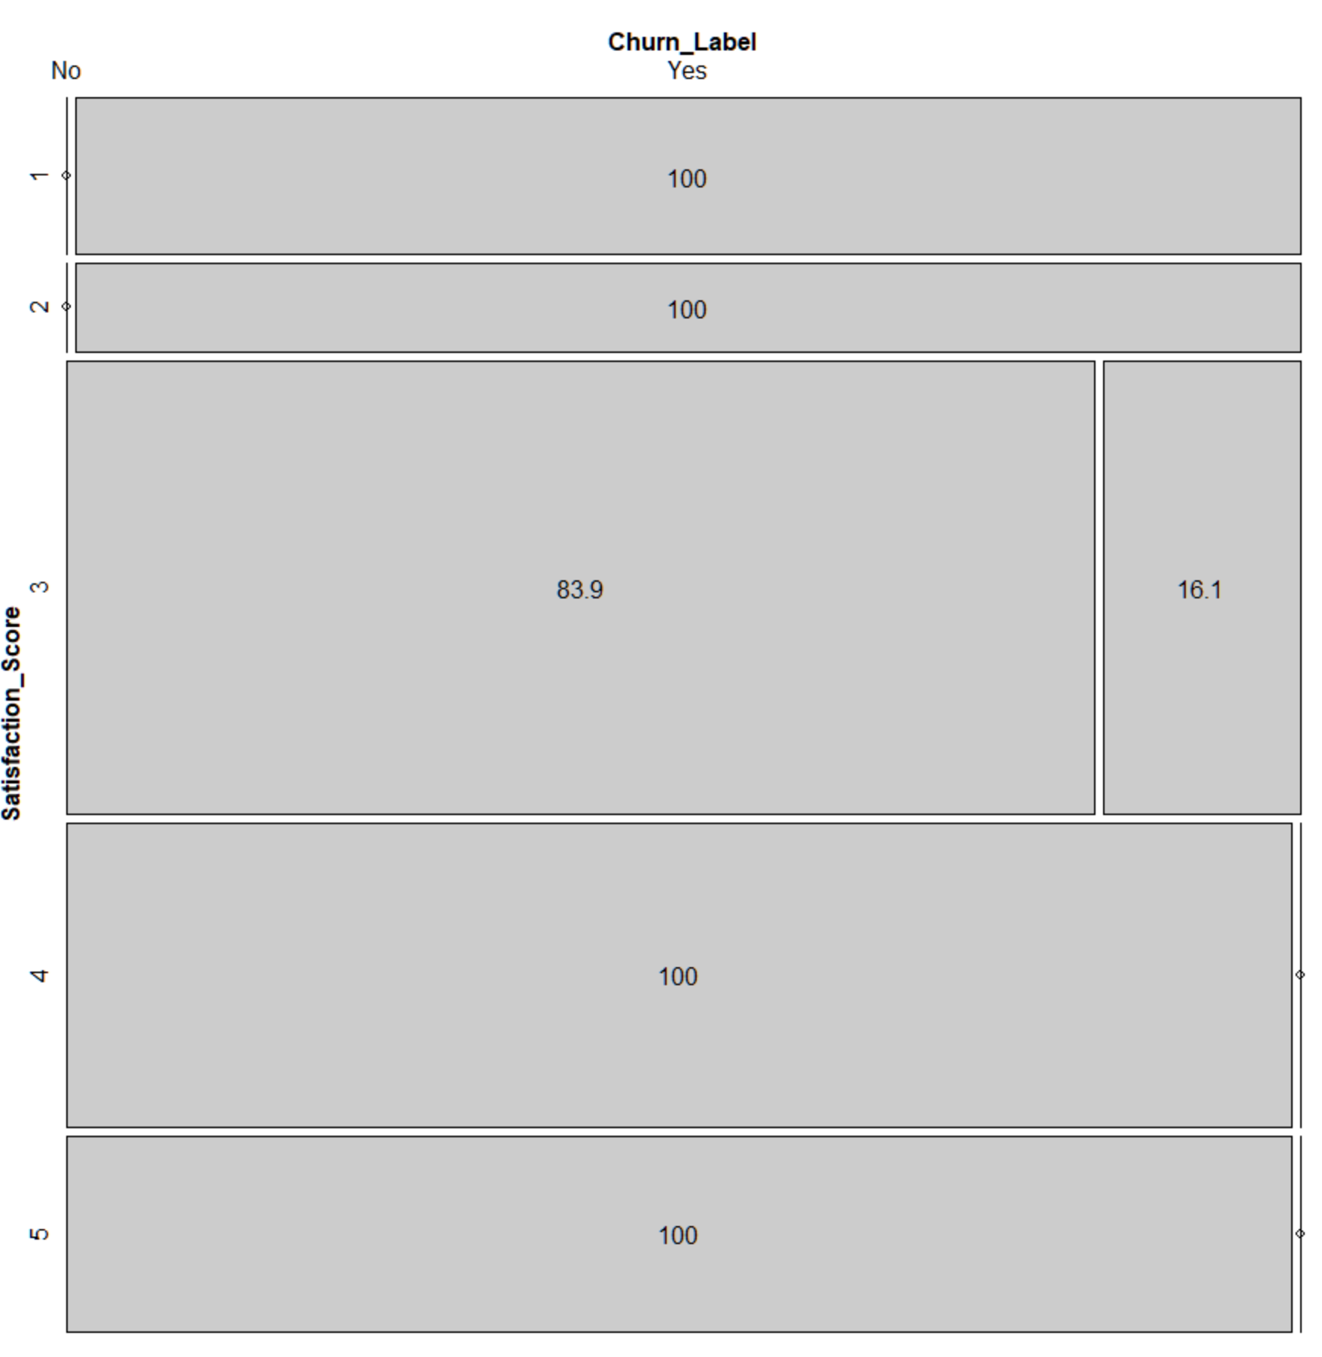

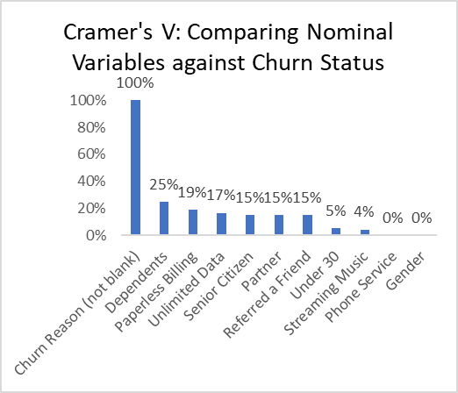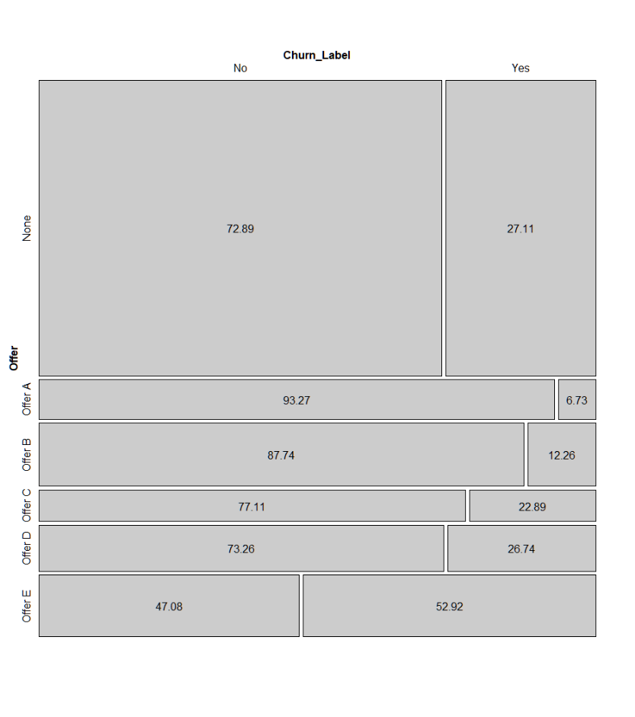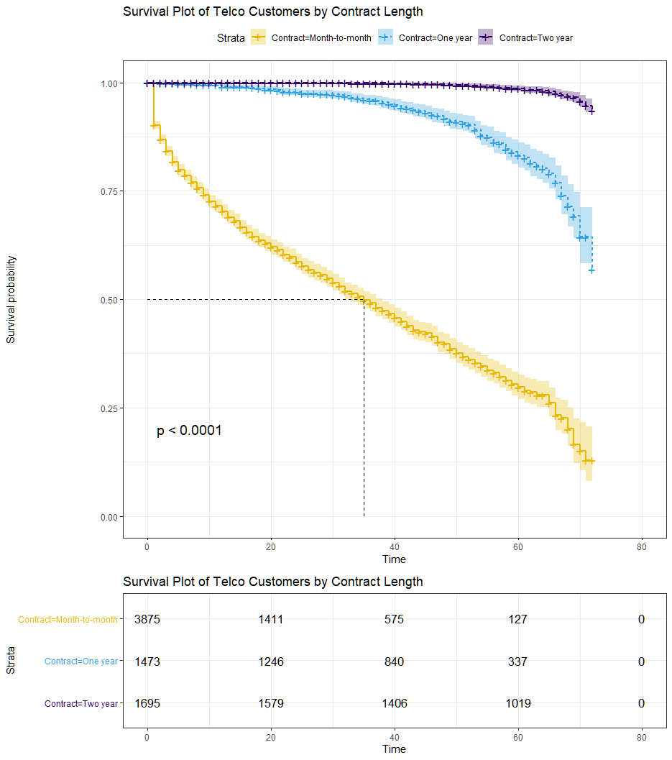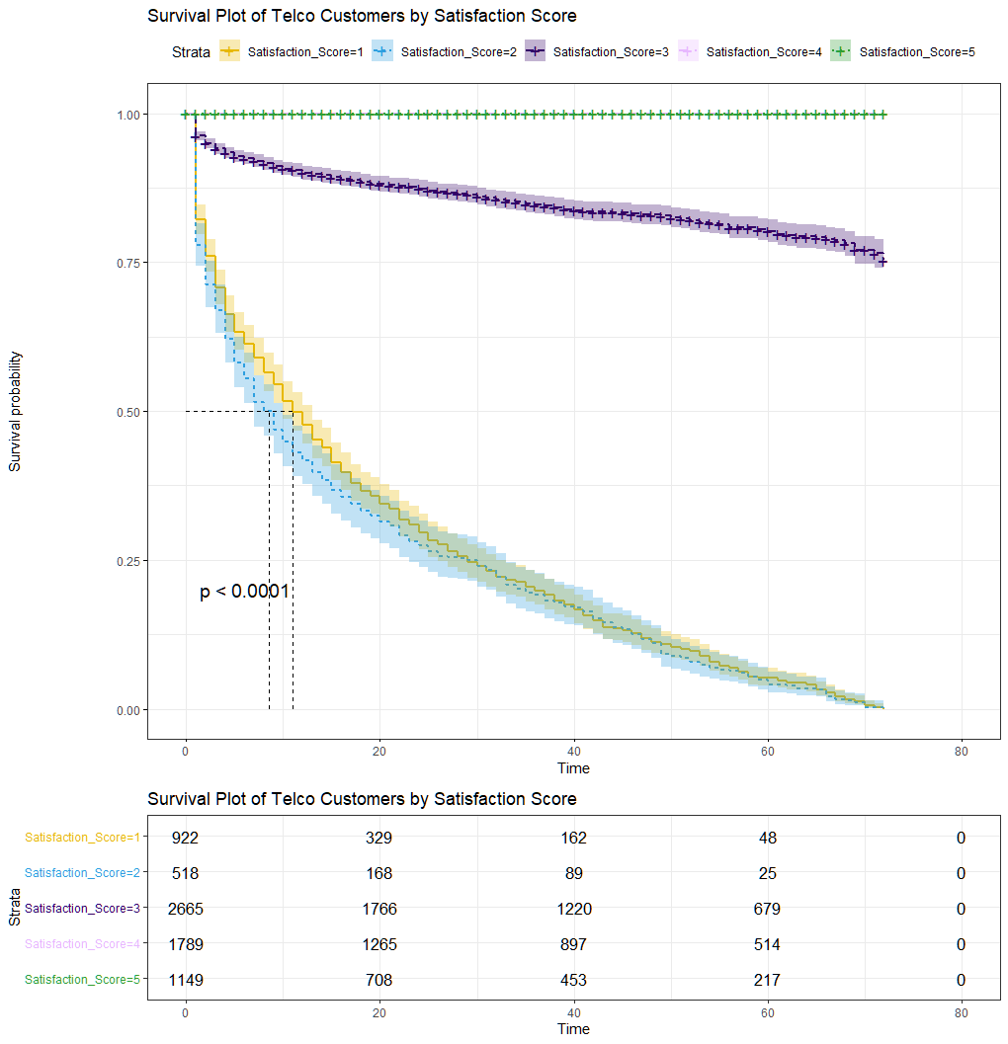

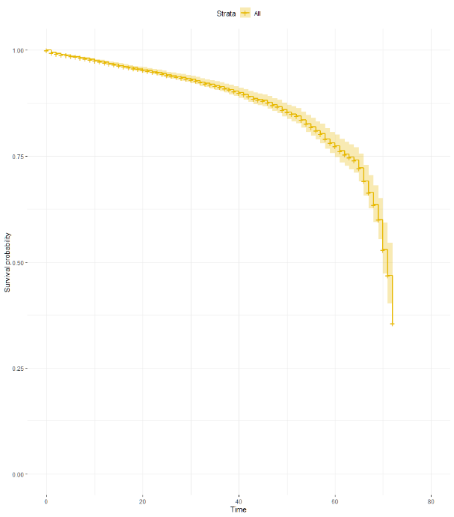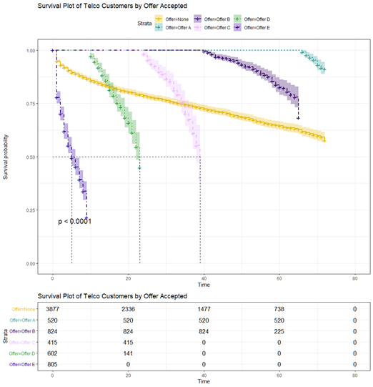

Seven-variable Cox Model, without strata

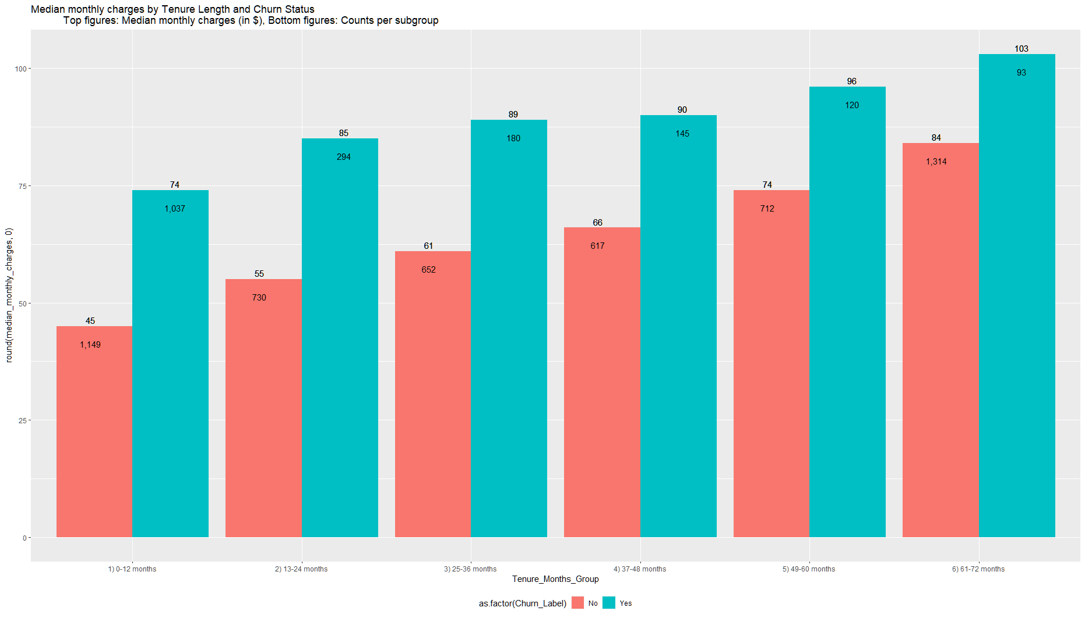

Chart 16: Schoenfeld Residuals of Seven-Variable Model

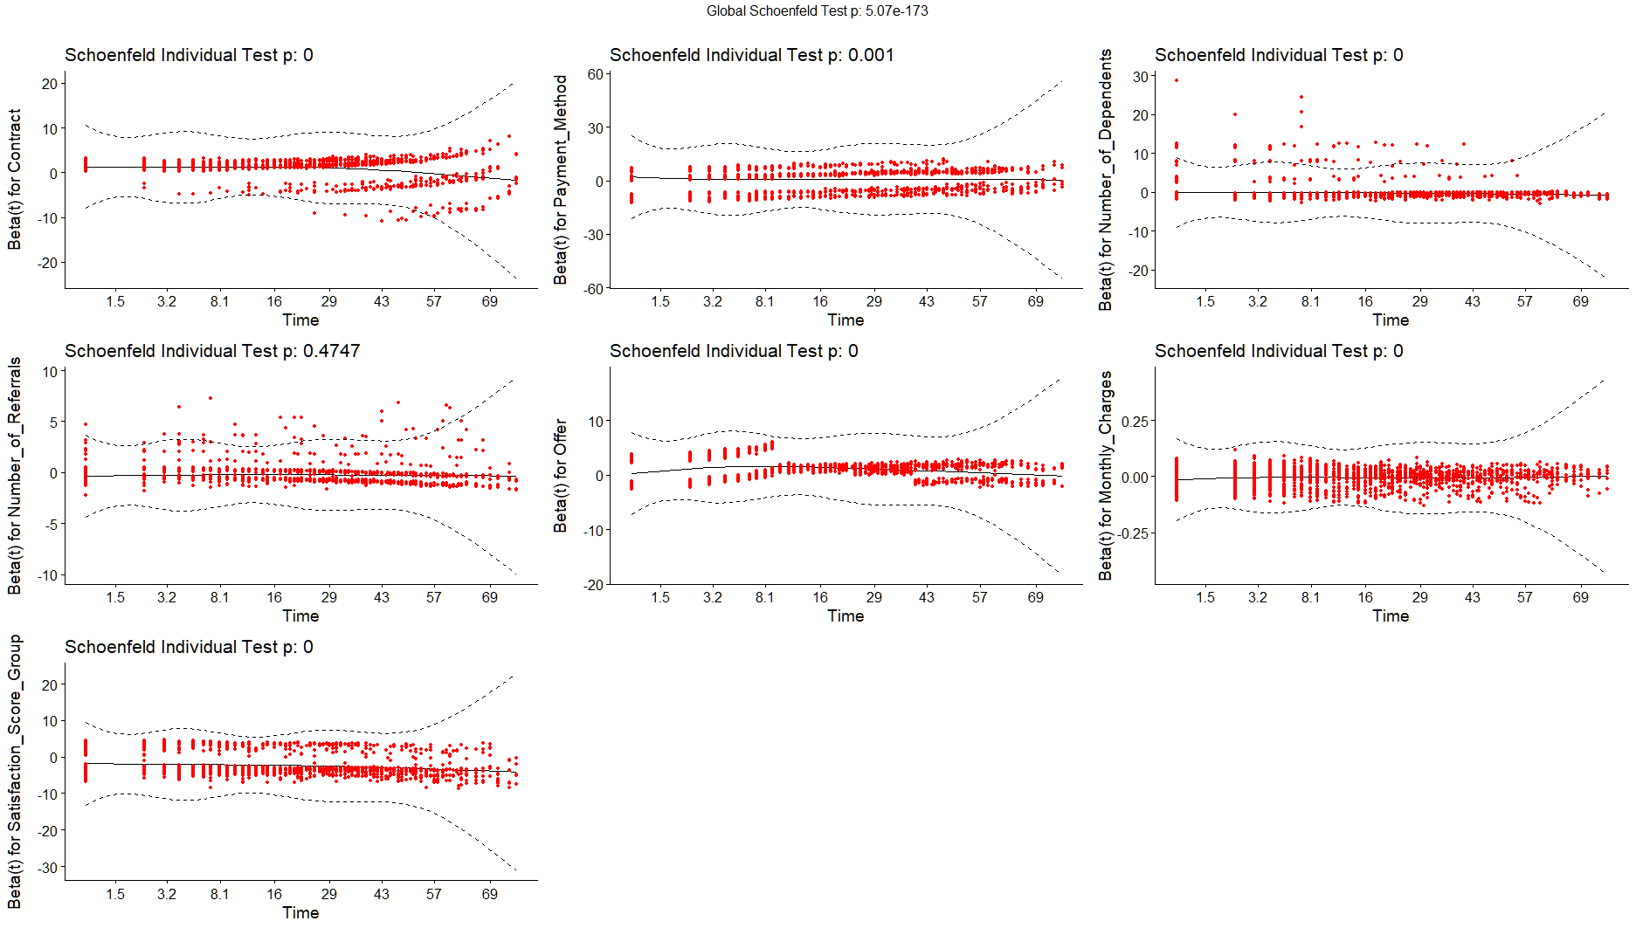

References

Data Set

1. Telco customer churn (11.1.3+) (2019). IBM Cognos Analytics sample data sets [Data set]. Kaggle. <https://www.kaggle.com/ylchang/telco-customer-churn-1113>

Other References (Listed Alphabetically)

1. “Cox Model Assumptions.” *STHDA (Statistical tools for high-throughput data analysis)*, <http://www.sthda.com/english/wiki/cox-model-assumptions>

Accessed December 12, 2020

1. IBM Business Solutions. “Telco customer churn (11.1.3+)” *IBM Community*, [https://community.ibm.com/community/user/businessanalytics/blogs/steven- macko/2019/07/11/telco-customer-churn-1113](https://community.ibm.com/community/user/businessanalytics/blogs/steven-%09macko/2019/07/11/telco-customer-churn-1113)

Accessed December 12, 2020

1. Kleinbaum, David G. and Klein, Mitchel. *Survival Analysis: A Self-Learning Text, Third Edition*. Springer Science, 2012. <https://www.springer.com/gp/book/9781441966452>
2. LaMorte, Wayne W. “Cox Proportional Hazards Regression Analysis.” *Boston University,* [https://sphweb.bumc.bu.edu/otlt/MPH- Modules/BS/BS704_Survival/BS704_Survival6.html](https://sphweb.bumc.bu.edu/otlt/MPH-%09Modules/BS/BS704_Survival/BS704_Survival6.html)

Accessed December 12, 2020

1. Luna, Jenny. “Why Every Business Will Soon Be a Subscription Business.” *Stanford Graduate School of Business*, [https://www.gsb.stanford.edu/insights/why-every- business-will- soon-be-subscription-business](https://www.gsb.stanford.edu/insights/why-every-%09business-will-%09soon-be-subscription-business)

Accessed December 12, 2020

1. Rizopoulos, Dimitris. “EP03: Survival Analysis in R Companion.” [https://www.drizopoulos.com/courses/emc/ep03_%20survival%20analysis%20i n%20r%20companion](https://www.drizopoulos.com/courses/emc/ep03_%20survival%20analysis%20i%09n%20r%20companion)

Accessed December 12, 2020